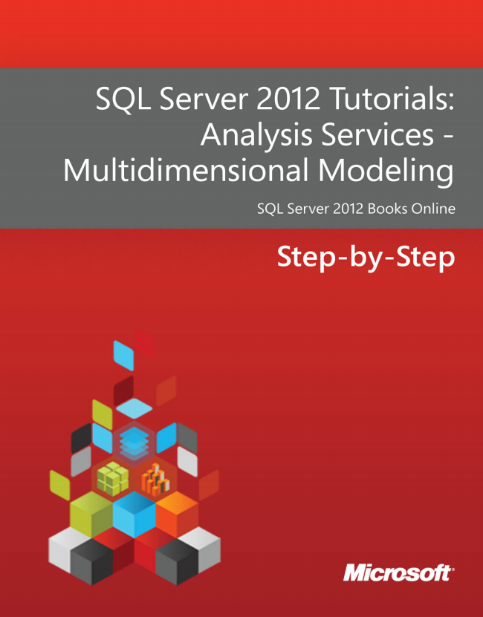

SQL Server 2012 Tutorials: Analysis Services - Multidimensional Modeling

SQL Server 2012 Books Online

Step-by-Step



**SQL Server 2012 Tutorials: Analysis Services - Multidimensional Modeling**

SQL Server 2012 Books Online

Summary: This tutorial describes how to use SQL Server Data Tools to develop and deploy an Analysis Services project, using the fictitious company Adventure Works Cycles for all examples.

Category: Step-by-Step Applies to: SQL Server 2012 Source: SQL Server Books Online (link to source content) E-book publication date: June 2012



Copyright © 2012 by Microsoft Corporation All rights reserved. No part of the contents of this book may be reproduced or transmitted in any form or by any means without the written permission of the publisher.

Microsoft and the trademarks listed at http://www.microsoft.com/about/legal/en/us/IntellectualProperty/Trademarks/EN-US.aspx are trademarks of the Microsoft group of companies. All other marks are property of their respective owners.

The example companies, organizations, products, domain names, email addresses, logos, people, places, and events depicted herein are fictitious. No association with any real company, organization, product, domain name, email address, logo, person, place, or event is intended or should be inferred.

This book expresses the author’s views and opinions. The information contained in this book is provided without any express, statutory, or implied warranties. Neither the authors, Microsoft Corporation, nor its resellers, or distributors will be held liable for any damages caused or alleged to be caused either directly or indirectly by this book.

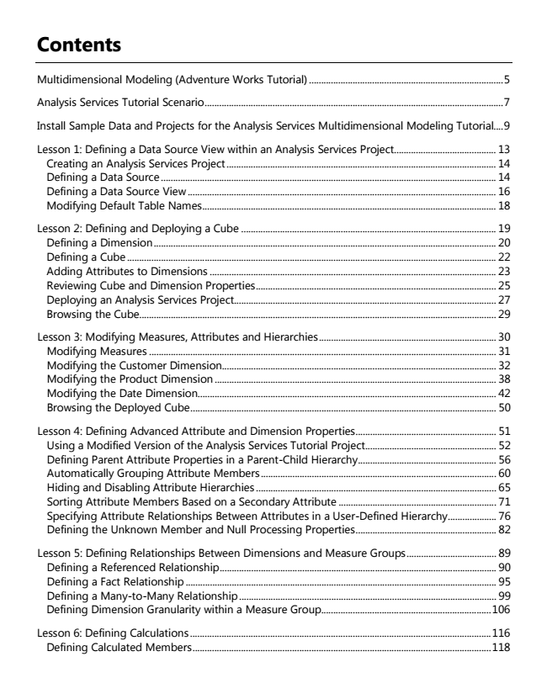

**Contents**

Multidimensional Modeling (Adventure Works Tutorial) ................................................................................ 5

Analysis Services Tutorial Scenario ........................................................................................................................... 7

Install Sample Data and Projects for the Analysis Services Multidimensional Modeling Tutorial.... 9

Lesson 1: Defining a Data Source View within an Analysis Services Project.......................................... 13 Creating an Analysis Services Project ............................................................................................................... 14 Defining a Data Source .......................................................................................................................................... 14 Defining a Data Source View ............................................................................................................................... 16 Modifying Default Table Names ......................................................................................................................... 18

Lesson 2: Defining and Deploying a Cube ......................................................................................................... 19 Defining a Dimension ............................................................................................................................................. 20 Defining a Cube ........................................................................................................................................................ 22 Adding Attributes to Dimensions ...................................................................................................................... 23 Reviewing Cube and Dimension Properties ................................................................................................... 25 Deploying an Analysis Services Project............................................................................................................ 27 Browsing the Cube................................................................................................................................................... 29

Lesson 3: Modifying Measures, Attributes and Hierarchies ......................................................................... 30 Modifying Measures ............................................................................................................................................... 31 Modifying the Customer Dimension................................................................................................................. 32 Modifying the Product Dimension .................................................................................................................... 38 Modifying the Date Dimension........................................................................................................................... 42 Browsing the Deployed Cube .............................................................................................................................. 50

Lesson 4: Defining Advanced Attribute and Dimension Properties .......................................................... 51 Using a Modified Version of the Analysis Services Tutorial Project ...................................................... 52 Defining Parent Attribute Properties in a Parent-Child Hierarchy ......................................................... 56 Automatically Grouping Attribute Members ................................................................................................. 60 Hiding and Disabling Attribute Hierarchies ................................................................................................... 65 Sorting Attribute Members Based on a Secondary Attribute ................................................................. 71 Specifying Attribute Relationships Between Attributes in a User-Defined Hierarchy .................... 76 Defining the Unknown Member and Null Processing Properties .......................................................... 82

Lesson 5: Defining Relationships Between Dimensions and Measure Groups ..................................... 89 Defining a Referenced Relationship .................................................................................................................. 90 Defining a Fact Relationship ................................................................................................................................ 95 Defining a Many-to-Many Relationship .......................................................................................................... 99 Defining Dimension Granularity within a Measure Group...................................................................... 106

Lesson 6: Defining Calculations ............................................................................................................................ 116 Defining Calculated Members ........................................................................................................................... 118

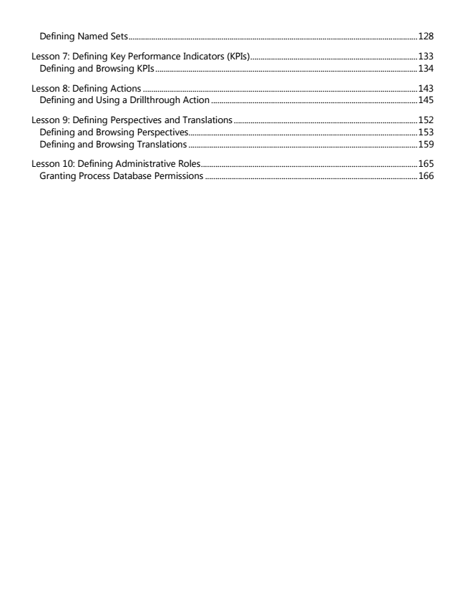

Defining Named Sets ............................................................................................................................................ 128

Lesson 7: Defining Key Performance Indicators (KPIs) ................................................................................. 133 Defining and Browsing KPIs ............................................................................................................................... 134

Lesson 8: Defining Actions ..................................................................................................................................... 143 Defining and Using a Drillthrough Action .................................................................................................... 145

Lesson 9: Defining Perspectives and Translations ......................................................................................... 152 Defining and Browsing Perspectives ............................................................................................................... 153 Defining and Browsing Translations ............................................................................................................... 159

Lesson 10: Defining Administrative Roles ......................................................................................................... 165 Granting Process Database Permissions ....................................................................................................... 166

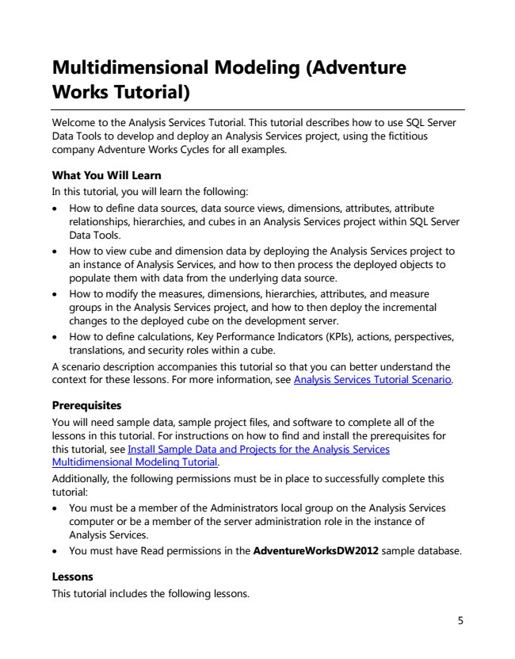

**Multidimensional Modeling (Adventure Works Tutorial)**

Welcome to the Analysis Services Tutorial. This tutorial describes how to use SQL Server Data Tools to develop and deploy an Analysis Services project, using the fictitious company Adventure Works Cycles for all examples.

What You Will Learn In this tutorial, you will learn the following:

• How to define data sources, data source views, dimensions, attributes, attribute relationships, hierarchies, and cubes in an Analysis Services project within SQL Server Data Tools.

• How to view cube and dimension data by deploying the Analysis Services project to an instance of Analysis Services, and how to then process the deployed objects to populate them with data from the underlying data source.

• How to modify the measures, dimensions, hierarchies, attributes, and measure groups in the Analysis Services project, and how to then deploy the incremental changes to the deployed cube on the development server.

• How to define calculations, Key Performance Indicators (KPIs), actions, perspectives, translations, and security roles within a cube. A scenario description accompanies this tutorial so that you can better understand the context for these lessons. For more information, see Analysis Services Tutorial Scenario.

Prerequisites You will need sample data, sample project files, and software to complete all of the lessons in this tutorial. For instructions on how to find and install the prerequisites for this tutorial, see Install Sample Data and Projects for the Analysis Services Multidimensional Modeling Tutorial. Additionally, the following permissions must be in place to successfully complete this tutorial:

• You must be a member of the Administrators local group on the Analysis Services computer or be a member of the server administration role in the instance of Analysis Services.

• You must have Read permissions in the AdventureWorksDW2012 sample database.

Lessons This tutorial includes the following lessons.

5

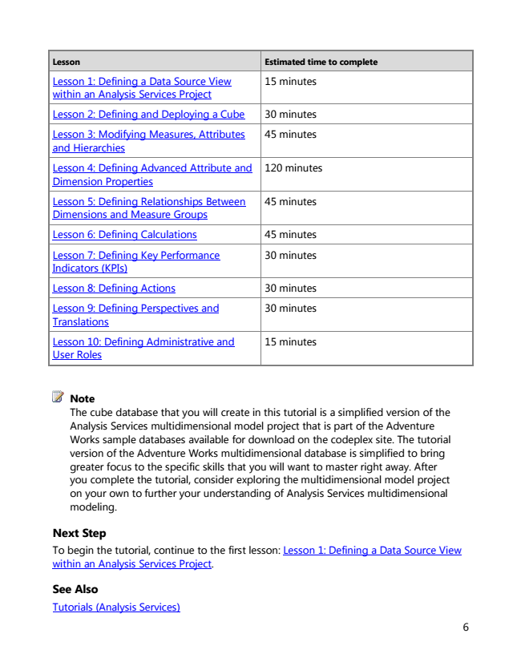

**Lesson Estimated time to complete**

Lesson 1: Defining a Data Source View within an Analysis Services Project

15 minutes

Lesson 2: Defining and Deploying a Cube 30 minutes

Lesson 3: Modifying Measures, Attributes and Hierarchies

45 minutes

Lesson 4: Defining Advanced Attribute and Dimension Properties

120 minutes

Lesson 5: Defining Relationships Between Dimensions and Measure Groups

45 minutes

Lesson 6: Defining Calculations 45 minutes

Lesson 7: Defining Key Performance Indicators (KPIs)

30 minutes

Lesson 8: Defining Actions 30 minutes

Lesson 9: Defining Perspectives and Translations

30 minutes

Lesson 10: Defining Administrative and User Roles

15 minutes

Note The cube database that you will create in this tutorial is a simplified version of the Analysis Services multidimensional model project that is part of the Adventure Works sample databases available for download on the codeplex site. The tutorial version of the Adventure Works multidimensional database is simplified to bring greater focus to the specific skills that you will want to master right away. After you complete the tutorial, consider exploring the multidimensional model project on your own to further your understanding of Analysis Services multidimensional modeling.

Next Step To begin the tutorial, continue to the first lesson: Lesson 1: Defining a Data Source View within an Analysis Services Project.

See Also Tutorials (Analysis Services)

6

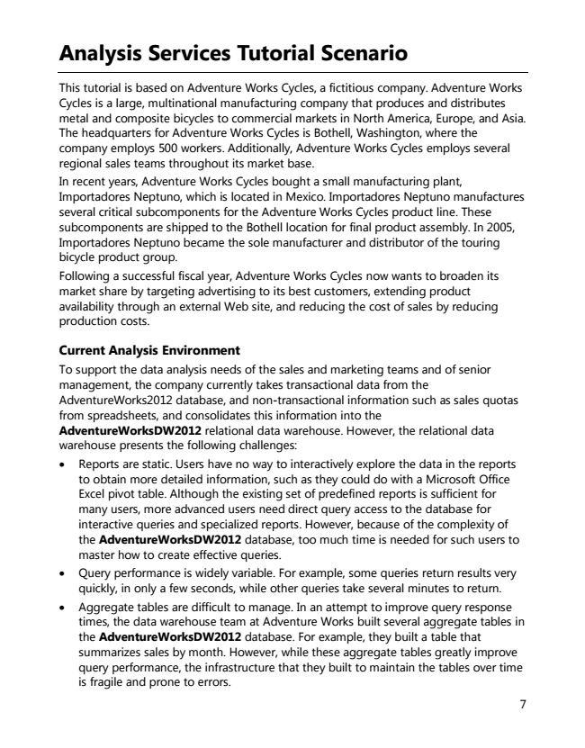

**Analysis Services Tutorial Scenario**

This tutorial is based on Adventure Works Cycles, a fictitious company. Adventure Works Cycles is a large, multinational manufacturing company that produces and distributes metal and composite bicycles to commercial markets in North America, Europe, and Asia. The headquarters for Adventure Works Cycles is Bothell, Washington, where the company employs 500 workers. Additionally, Adventure Works Cycles employs several regional sales teams throughout its market base. In recent years, Adventure Works Cycles bought a small manufacturing plant, Importadores Neptuno, which is located in Mexico. Importadores Neptuno manufactures several critical subcomponents for the Adventure Works Cycles product line. These subcomponents are shipped to the Bothell location for final product assembly. In 2005, Importadores Neptuno became the sole manufacturer and distributor of the touring bicycle product group. Following a successful fiscal year, Adventure Works Cycles now wants to broaden its market share by targeting advertising to its best customers, extending product availability through an external Web site, and reducing the cost of sales by reducing production costs.

Current Analysis Environment To support the data analysis needs of the sales and marketing teams and of senior management, the company currently takes transactional data from the AdventureWorks2012 database, and non-transactional information such as sales quotas from spreadsheets, and consolidates this information into the AdventureWorksDW2012 relational data warehouse. However, the relational data warehouse presents the following challenges:

• Reports are static. Users have no way to interactively explore the data in the reports to obtain more detailed information, such as they could do with a Microsoft Office Excel pivot table. Although the existing set of predefined reports is sufficient for many users, more advanced users need direct query access to the database for interactive queries and specialized reports. However, because of the complexity of the AdventureWorksDW2012 database, too much time is needed for such users to master how to create effective queries.

• Query performance is widely variable. For example, some queries return results very quickly, in only a few seconds, while other queries take several minutes to return.

• Aggregate tables are difficult to manage. In an attempt to improve query response times, the data warehouse team at Adventure Works built several aggregate tables in the AdventureWorksDW2012 database. For example, they built a table that summarizes sales by month. However, while these aggregate tables greatly improve query performance, the infrastructure that they built to maintain the tables over time is fragile and prone to errors.

7

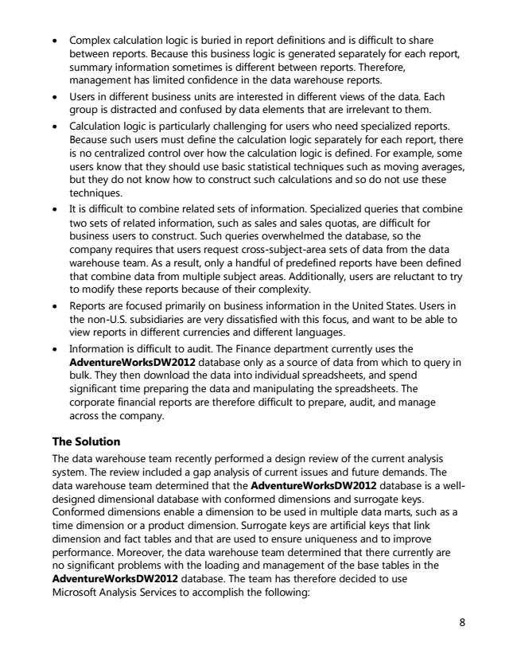

• Complex calculation logic is buried in report definitions and is difficult to share between reports. Because this business logic is generated separately for each report, summary information sometimes is different between reports. Therefore, management has limited confidence in the data warehouse reports.

• Users in different business units are interested in different views of the data. Each group is distracted and confused by data elements that are irrelevant to them.

• Calculation logic is particularly challenging for users who need specialized reports. Because such users must define the calculation logic separately for each report, there is no centralized control over how the calculation logic is defined. For example, some users know that they should use basic statistical techniques such as moving averages, but they do not know how to construct such calculations and so do not use these techniques.

• It is difficult to combine related sets of information. Specialized queries that combine two sets of related information, such as sales and sales quotas, are difficult for business users to construct. Such queries overwhelmed the database, so the company requires that users request cross-subject-area sets of data from the data warehouse team. As a result, only a handful of predefined reports have been defined that combine data from multiple subject areas. Additionally, users are reluctant to try to modify these reports because of their complexity.

• Reports are focused primarily on business information in the United States. Users in the non-U.S. subsidiaries are very dissatisfied with this focus, and want to be able to view reports in different currencies and different languages.

• Information is difficult to audit. The Finance department currently uses the AdventureWorksDW2012 database only as a source of data from which to query in bulk. They then download the data into individual spreadsheets, and spend significant time preparing the data and manipulating the spreadsheets. The corporate financial reports are therefore difficult to prepare, audit, and manage across the company.

The Solution The data warehouse team recently performed a design review of the current analysis system. The review included a gap analysis of current issues and future demands. The data warehouse team determined that the AdventureWorksDW2012 database is a well- designed dimensional database with conformed dimensions and surrogate keys. Conformed dimensions enable a dimension to be used in multiple data marts, such as a time dimension or a product dimension. Surrogate keys are artificial keys that link dimension and fact tables and that are used to ensure uniqueness and to improve performance. Moreover, the data warehouse team determined that there currently are no significant problems with the loading and management of the base tables in the AdventureWorksDW2012 database. The team has therefore decided to use Microsoft Analysis Services to accomplish the following:

8

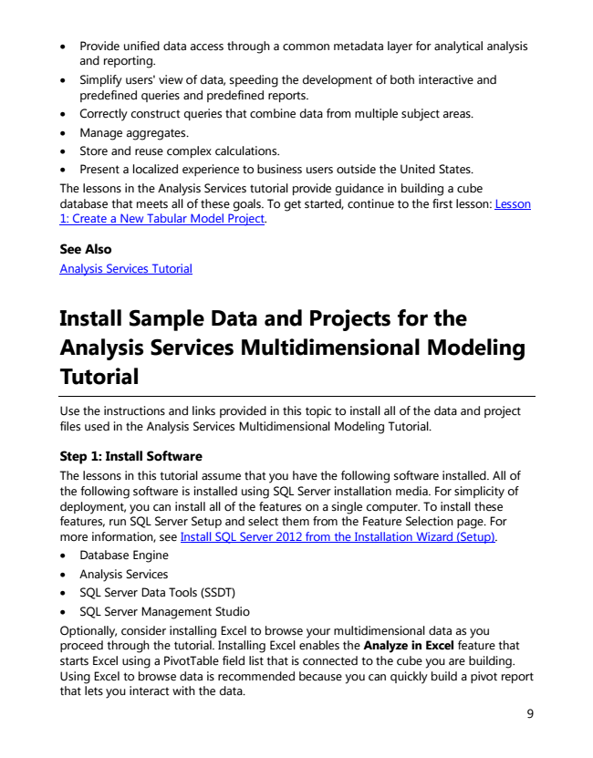

• Provide unified data access through a common metadata layer for analytical analysis and reporting.

• Simplify users' view of data, speeding the development of both interactive and predefined queries and predefined reports.

• Correctly construct queries that combine data from multiple subject areas.

• Manage aggregates.

• Store and reuse complex calculations.

• Present a localized experience to business users outside the United States. The lessons in the Analysis Services tutorial provide guidance in building a cube database that meets all of these goals. To get started, continue to the first lesson: Lesson 1: Create a New Tabular Model Project.

See Also Analysis Services Tutorial

**Install Sample Data and Projects for the Analysis Services Multidimensional Modeling Tutorial**

Use the instructions and links provided in this topic to install all of the data and project files used in the Analysis Services Multidimensional Modeling Tutorial.

Step 1: Install Software The lessons in this tutorial assume that you have the following software installed. All of the following software is installed using SQL Server installation media. For simplicity of deployment, you can install all of the features on a single computer. To install these features, run SQL Server Setup and select them from the Feature Selection page. For more information, see Install SQL Server 2012 from the Installation Wizard (Setup).

• Database Engine

• Analysis Services

• SQL Server Data Tools (SSDT)

• SQL Server Management Studio Optionally, consider installing Excel to browse your multidimensional data as you proceed through the tutorial. Installing Excel enables the Analyze in Excel feature that starts Excel using a PivotTable field list that is connected to the cube you are building. Using Excel to browse data is recommended because you can quickly build a pivot report that lets you interact with the data.

9